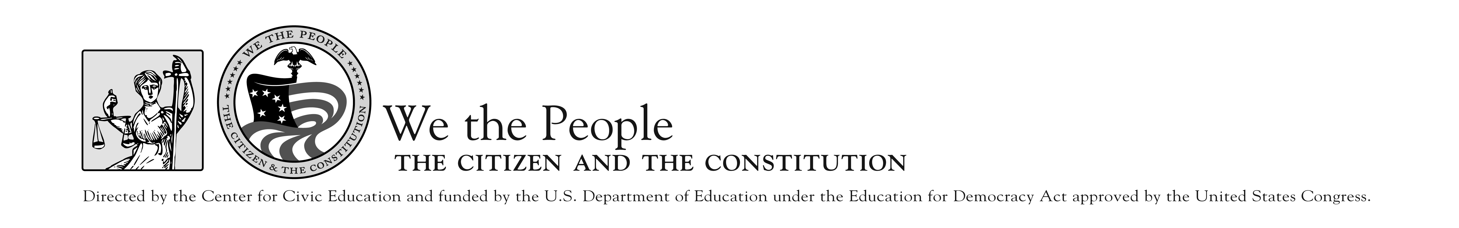

“There are those who write history. There are those who make history. There are those who experience history. I don’t know how many historians we have in Birmingham tonight. I don’t know many of you would be able to write a history book. But you certainly are making history, and you are experiencing history. And you will make it possible for historians of the future to write a marvelous chapter. Never in the history of this nation have so many people been arrested for the cause of freedom and human dignity!”
MLK, 1963

“The Children’s March in Birmingham, Alabama during May of 1963 is a glorious example of citizens securing the blessings of liberty by demanding their constitutional rights and justice in the face of the government’s water hoses, dogs and laws. Young people led by Southern Baptist preachers, not government, changed America!” RSL, 2005

