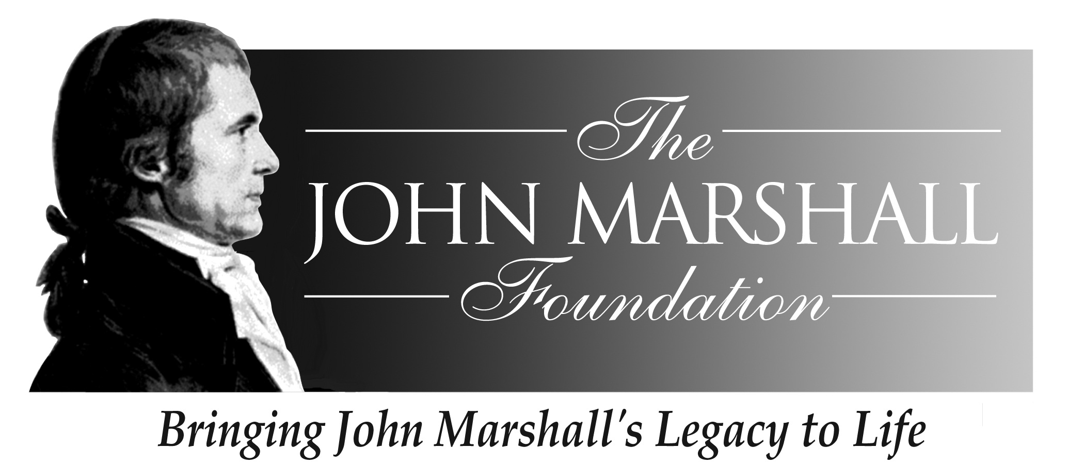

John Marshall Seminar
The Man and His Judicial Philosophy
May 6 – 9, 2010

Sponsored by
The John Marshall Foundation
And
The Center for Civic Education
And
The Library of Virginia

The Hilton Garden Inn
Richmond Downtown
501 East Broad Street, Richmond, VA 23219
(804) 344-4300

Thursday, May 6

12:00 -- 6:00 Seminar Registration and check-in The Hilton Garden Inn

6:00 – 6:30 Meet John Marshall and our The Hilton Garden Inn conference attendees meeting room
6:30 Walk to Gibson’s Grille

6:35 -- 8:30 Reception/Dinner Gibson’s Grille
700 E. Broad Street
Welcome
Lynn Brackenridge, Executive Director

The John Marshall Foundation

Robert Leming
Director, We the People: the Citizen and the Constitution
The Center for Civic Education

Mark Greenough, Supervisor and Historian
Capitol Guided Tours
Commonwealth of Virginia

Friday, May 7

7:30 -- 8:15 Breakfast (voucher #1) Hilton Garden Inn
* Wear comfortable walking shoes today

* Pick up a bottle of water from the Hilton
front desk before leaving the hotel

8:30 Walk to Historic John Marshall House
8:45 -- 10:00 Tour of the John Marshall House and Gardens
John Marshall House Docents

10:00 -- 12:00 Walking Tour of John Marshall’s Richmond
Chief Justice John Marshall (Mark Greenough)

12:00 – 12:45 Questions and Answers with Chief Justice Supreme Court
Marshall at the Supreme Court of Virginia of Virginia
*Please note: Court Regulations forbid any food
or drink in the courtroom

12:45 Walk to the Library of Virginia

12:50 – 1:20 Lunch Library of Virginia
1:20 – 2:00: Activities/lessons and Resources from the Library of
Virginia
Tameka B. Hobbs
Program and Education Coordinator
The Library of Virginia

2:00 - 3:30 Presentation by Tom Camden
Director, Special Collections,
Library of Virginia

3:30 Walk back to Hilton Garden Inn

3:35 – 5:30 Relax on your own!
Prepare for reception and dinner (smart casual attire)

5:30-6:30 Reception Hilton Garden Inn Ballroom

6:30-8:30 Dinner Hilton Garden Inn Ballroom

Welcome
Ralph B. Higgins
President, Board of Directors, The John Marshall Foundation
And Descendent of John Marshall

The Colonial Dance Club of Richmond will entertain us with an evening of Early American dancing. The Club, established in 1977,
is dedicated to the promotion and preservation of English Country
Dancing. Chief Justice John Marshall often enjoyed dancing.
Saturday, May 8

7:30 -- 8:15 Breakfast (voucher #2) Hilton Garden Inn
* Wear comfortable walking shoes today

* Pick up a bottle of water from the Hilton
front desk before leaving the hotel

8:15 Walk to the University of Richmond School
of Law’s Harry L. Carrico Pro Bono Center

8:30 – 10:30 “You are a Supreme Court Justice” Pro Bono Center
Matthew Gutwein, Professor of Law,
Indiana University

10:30 – 10:45 Break

10:45 – 12:15 The Cherokee Nation Cases Pro Bono Center
Robert Leming
Director, We the People:the Citizen and the Constitution
The Center for Civic Education

12:15 – 1:15 Lunch /video Pro Bono Center

John Marshall: In the Opinion of the Court-- a 29-minute video
Showing how Marshall’s leadership cemented
the role of the Supreme Court as the Law of the Land

1:30 – 2:30 John Marshall, The Man and His Writings Pro Bono Center
Charles F. Hobson
Editor of The Papers of John Marshall
Institute of Early American History and Culture
College of William and Mary
2:30 Walk from the Library to Monumental Church

2:40 – 3:30 Tour of Monumental Church
Historic Richmond Foundation

3:30 Walk back to the Hilton Garden Inn for a chance to relax (finally!)
and to have dinner on your own! (See the front desk or the JMF
staff for suggestions for nearby restaurants)

7:30 – 8:30 Dessert and Discussion Hilton Garden Inn
Marbury v. Madison Meeting Room
John J. Patrick,
Professor of Education Emeritus,
Indiana University
*Please remember to bring your copy of Marbury v. Madison:
The Origins and Legacy of Judicial Review by William E. Nelson.

Sunday, May 9

7:30 – 8:30 Breakfast (voucher #3) and check out Hilton Garden Inn
* Your luggage can be stored in the room where we will be meeting.

8:30 – 10:30 Beyond Marbury: The Impact of the John Hilton Garden Inn
Marshall Court Meeting Room
John J. Patrick,
Professor of Education Emeritus,
Indiana University

10:30 – 10:45 Break

10:45 – 11:30 Professor Patrick, continued

11:30 – 12:00 John Marshall and We The People: The Citizen and the Constitution
Robert Leming Director, We the People Program,
Center for Civic Education

12:00 – 12:15 Complete and submit seminar evaluations

12:15 Box Lunch to Go /End of Seminar

*The JMF staff will order Groome Shuttles to take you back to the Airport in plenty of time to catch your flight.

