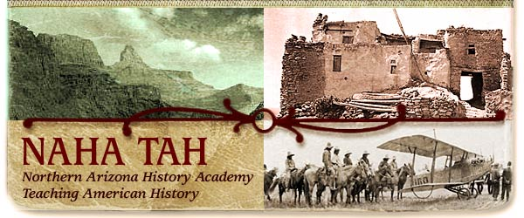

The Navajo Nation Experience
September 21-24, 2012

Chinle Unified School District Boardroom

Friday, September 21st ____________________________________________________

3:00-5:30 Hotel Check in Holiday Inn

6:00-6:30 Reception Holiday Inn

6:30-8:30 Welcome, Introductions and Dinner Holiday Inn
Linda Sargent Wood, Associate Professor of History
Project Director,
Northern Arizona History Academy TAH Grant

Robert S. Leming, Director of We the People Programs
Center for Civic Education

Saturday, September 22nd _________________________________________________

8:00-9:00 Breakfast

9:00-10:30 The History of the Navajos Board Room
Steve Pavlik, Professor of Native American
Studies & Native Environmental Science

10:30-10:45 Break

10:45-12:00 The Long Walk: Tears of the Navajo Board Room
Film

12:00-1:00 Lunch Board Room

2:00-8:00 Canyon De Chelly: Navajo History and Culture

Sunday, September 23rd ___________________________________________________

8:00-9:00 Breakfast Board Room

9:00-10:30 Reclaiming Dine History: The Legacies
Of Navajo Chief Manuelito and Juanita
Jennifer Denetdale, Associate Professor of American Studies, University of New Mexico

10:30-10:45 Break

10:45-12:00 Navajo Citizenship and Constitutional Law Board Room
David Wilkins, Professor of History
University of Minnesota

12:00-1:00 Lunch

1:00 – 2:45 Navajo Citizenship and Constitutional Law – Part II Boardroom David Wilkins

2:45-3:00 Break

3:00-4:00 Citizenship Counts
Tina Ochoa, Education Coordinator
Citizenship Counts

4:00-4:45 Arizona Foundation for Legal Services & Education Teaching Resources
Jennifer Castro, Professional Development Manager
Arizona Foundation for Legal Services & Education

Monday, September 24th ______________________________________________
7:30-8:00 Breakfast Board Room

8:00-9:30 Tribal Sovereignty vs. Equal Protection of the Laws
Robert S. Leming

9:30-9:45 Break

9:45-10:30 The Navajo Judicial System (Overview) Board Room
LaVerne Garnenez, Law Clerk
Navajo Nation Supreme Court

10:30-11:30 Struggle Between Traditional Law/Customs Board Room
and Western Law
Chief Justice Herb Yazzie
Navajo Nation Supreme Court

11:30 Lunch & Departure

