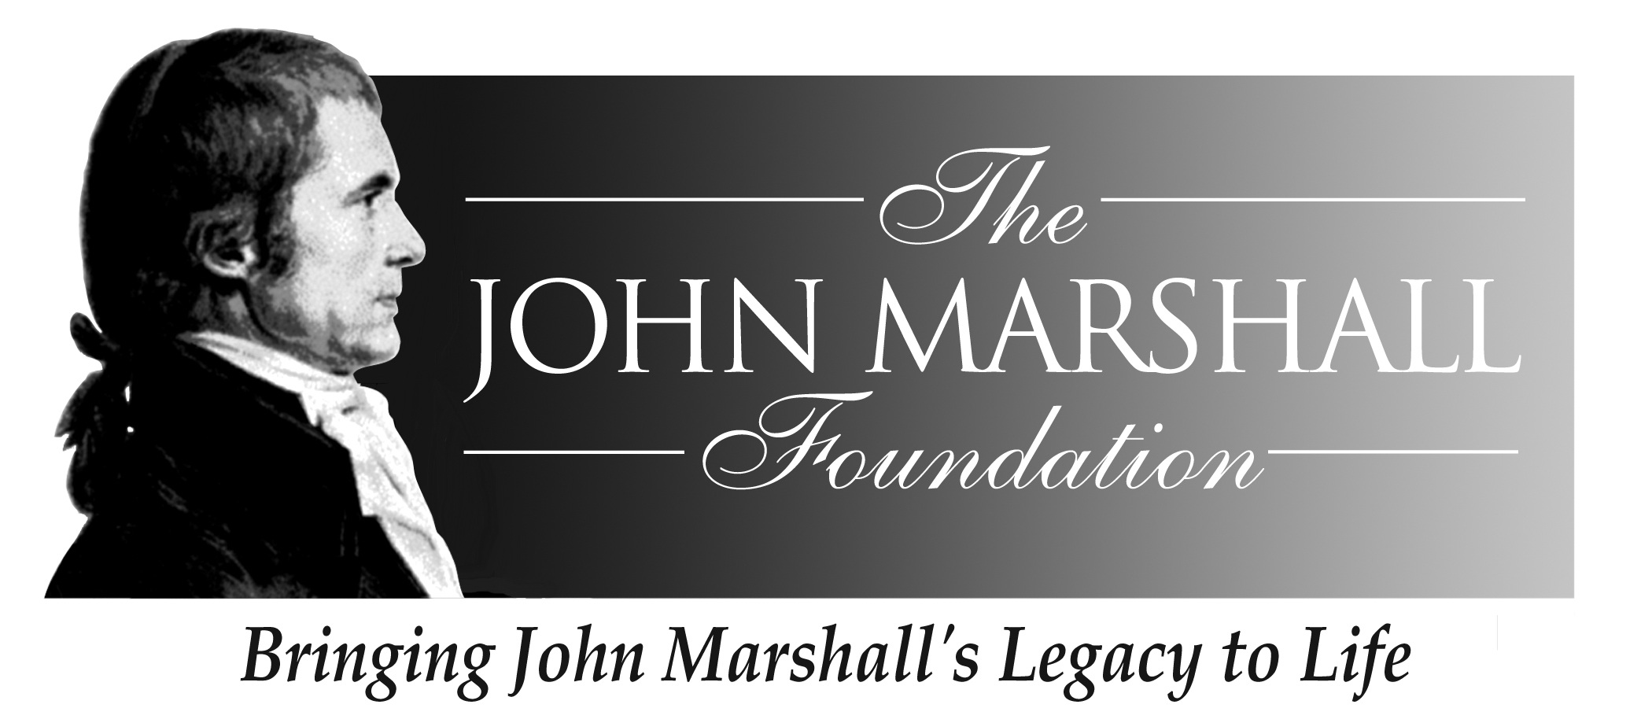

John Marshall Seminar
The Man and His Judicial Philosophy
October 29 – November 1, 2009

Sponsored by
The John Marshall Foundation
And
The Center for Civic Education
And
The Library of Virginia

The Hilton Garden Inn
Richmond Downtown
501 East Broad Street, Richmond, VA 23219
(804) 344-4300

Thursday, October 29

12:00-6:00 Seminar Registration The Hilton Garden Inn

6:20 Walk to Gibson’s Grille

6:30-8:30 Reception/Dinner Gibson’s Grille
700 E. Broad Street
Welcome
Lynn Brackenridge, Executive Director

The John Marshall Foundation

Robert Leming
Director, We the People Program
Center for Civic Education

Mark Greenough, Supervisor and Historian
Capitol Guided Tours
Commonwealth of Virginia

Friday, October 30

7:30-8:30 Breakfast Hilton Garden Inn

8:45 Walk to Historic John Marshall House
9:00-9:45 John Marshall Historical Sites John Marshall House
The Hollow, Oak Hill, Mont Blanc
Gravesite, Shockoe Hill Cemetery
Louis Malon
Director, Preservation Services
APVA Preservation Virginia

9:45-10:30 Tour of the John Marshall House and Garden
John Marshall House Docents

10:30-10:45 Walk across Marshall Street to the Library of Virginia

10:45-11:45 John Marshall the Man
Mr. Chief Justice, 58-minute video depicting the first “lawyer’s dinner” following Marshall’s appointment as Chief Justice and the inauguration of Thomas Jefferson

11:45 – 12:30 Box lunches at the Library

12:30 – 1:30 Activities, Lessons and Resources for Incorporating the Life and Legacy of John Marshall and the Constitution into the Classroom
Brian Keith Hillman
Victory Christian Academy \
Richmond, VA
(Winner of the 2009 John Marshall Foundation Teachers Award)

Tameka B. Hobbs
Library and Education Coordinator
The Library of Virginia

Barbara A. Schneider
Coordinator, Education Programs
The John Marshall Foundation

1:30 – 1:45 Break

1:45 – 3:00 Presentation by Tom Camden The Library of Virginia
Director, Special Collections,
Library of Virginia

3:00 Walk from the Library to Monumental Church
Katelyn B. Kelley
Preservation and Marketing Manager
Historic Richmond Foundation

4:15 Walk back to Hilton Garden Inn from Monumental Church

4:30 – 5:30 Relax on your own!

5:30-6:30 Reception Hilton Garden Inn Ballroom

6:30-8:30 Dinner Hilton Garden Inn Ballroom

Welcome
Ralph B. Higgins
President, Board of Directors, The John Marshall Foundation
And Descendent of John Marshall

The Colonial Dance Club of Richmond will entertain us with an evening of Early American dancing. The Club, established in 1977,
is dedicated to the promotion and preservation of English Country
Dancing. Chief Justice John Marshall often enjoyed dancing.

Saturday, October 31

8:00-8:30 Breakfast Hilton Garden Inn

8:30 Walk to Supreme Court of Virginia
9:00 – 10:30 “You are a Supreme Court Justice” Supreme Court
Matthew Gutwein, Professor of Law,
Indiana University

10:30-10:45 Break

10:45-12:45 John Marshall and the Cherokee Nation Cases
Stephen Bragaw, Associate Professor and Chair of
The Department of Government
Sweet Briar College

12:45-1:30 Return to the Hilton Garden Inn for lunch on your own

2:00-4:00 Walking Tour of John Marshall’s Richmond
Chief Justice John Marshall (Mark Greenough)
(Meet in the Lobby of the Hilton Garden Inn at 2:00)

(Be sure to wear comfortable walking shoes!)

4:00-4:45 Questions and Answers with Chief Justice Marshall at the Virginia Supreme Court

4:45 Shuttle/walk/carpool from Supreme Court to Hunton & Williams, 951 E. Byrd Street

5:00-6:30 Wine and Cheese Party at Hunton & Williams

6:30 - Dinner on Your Own

Sunday, November 1

8:00 – 9:00 Buffet Breakfast Hilton Garden Inn Meeting Room

9:00 – 11:00 Beyond Marbury: The Impact of the John Hilton Garden Inn
Marshall Court Meeting Room
John J. Patrick,
Professor of Education Emeritus,
Indiana University

11:00 – 11:15 Break

11:15 – 11:45 Overview of John Marshall Foundation’s Education Programs
Barbara Schneider, Coordinator, Education Programs
The John Marshall Foundation

11:45 – 12:15 John Marshall and We The People: The Citizen and the Constitution
Robert Leming Director, We the People Program,
Center for Civic Education

12:15 – 12:30 Complete and submit seminar evaluations

12:30 Box Lunch and Hotel Check-out

