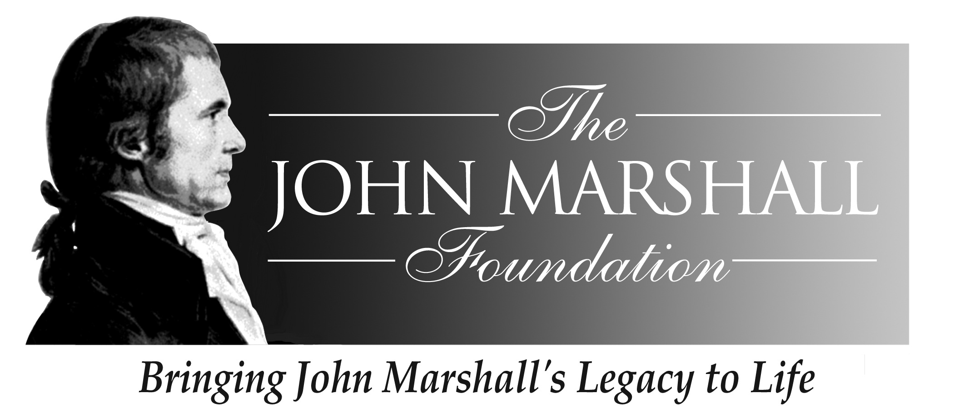

John Marshall Seminar
The Man and His Judicial Philosophy
May 7 – May 10, 2009

Sponsored by
The John Marshall Foundation
And
The Center for Civic Education
And
The Library of Virginia

The Downtown Marriott Hotel Richmond
500 East Broad Street, Richmond, VA
(804) 643-3400

Thursday, May 7

12:00-6:00 Seminar Registration The Richmond Marriott

6:30-8:30 Reception/Dinner Gibson’s Grill
700 E. Broad Street
Welcome
Lynn Brackenridge, Executive Director

The John Marshall Foundation

Jin Kim,
Assistant Director, We the People Program
Center for Civic Education

Mark Greenough, Supervisor and Historian
Capitol Guided Tours
Commonwealth of Virginia

Friday, May 8

7:30-8:30 Breakfast Marriott Hotel

8:45 Walk to Historic John Marshall House
9:00-9:45 John Marshall Historical Sites John Marshall House
The Hollow, Oak Hill, Mont Blanc
Gravesite, Shockoe Hill Cemetery

Louis Malon
Director, Preservation Services
APVA Preservation Virginia

9:45-10:30 Tour of the John Marshall House and Garden
John Marshall House Docents

10:30-10:45 Walk across Marshall Street to the Library of Virginia

10:45-11:45 John Marshall the Man
Mr. Chief Justice, 58-minute video depicting the first “lawyer’s dinner” following Marshall’s appointment as Chief Justice and the inauguration of Thomas Jefferson

11:45 – 12:00 Break

12:00 – 1:00 Book talks, signing and box lunch The Library of Virginia
John Marshall, Revolutionary War Hero
Keith Marshall Jones, III, author
“Congress As My Government”: Chief Justice John Marshall in
The American Revolution and
Cliff Sloan and David McKean, authors
The Great Decision: Jefferson, Adams, Marshall and the Battle for the Supreme Court
(Both books will be available for purchase at the Library)

1:30 – 2:30 Depart from the Library of Virginia for optional Shockoe Hill
Cemetery Tour

2:30 Return to Marriott from Shockoe Hill Cemetery Tour

4:15 Walk back to Library of Virginia

4:30 -- 5:45 Presentation by Tom Camden The Library of Virginia
Director, Special Collections,
Library of Virginia

6:00-6:30 Reception Library of Virginia

6:30-8:30 Dinner Library of Virginia

Welcome
Ralph B. Higgins
President, Board of Directors, The John Marshall Foundation
And Descendent of John Marshall

The Colonial Dance Club of Richmond will entertain us with an evening of Early American dancing. The Club, established in 1977,
is dedicated to the promotion and preservation of English Country
Dancing. Chief Justice John Marshall often enjoyed dancing.

Saturday, May 9

8:00-8:30 Breakfast Marriott Hotel

8:30 Walk to Supreme Court of Virginia
9:00 – 10:30 “You are a Supreme Court Justice” Supreme Court
Matthew Gutwein, Professor of Law,
Indiana University

10:30-10:45 Break

10:45-12:45 John Marshall and the Cherokee Nation Cases David Eugene Wilkins
University of Minnesota Law School

12:45-1:30 Return to the Marriott for lunch on your own

2:00-4:00 Walking Tour of John Marshall’s Richmond
Chief Justice John Marshall (Mark Greenough)
(Meet in the Lobby of the Marriott at 2:00)

4:00-4:45 Questions and Answers with Chief Justice Marshall at the Virginia Supreme Court

4:45 Shuttle/walk/carpool from Supreme Court to Hunton & Williams, 951 E. Byrd Street

5:00-6:30 Wine and Cheese Party at Hunton & Williams

6:30 - Dinner on Your Own

Sunday, May 10

8:00 – 9:00 Breakfast Marriott Hotel
9:00 – 11:00 Beyond Marbury: The Impact of the John Marshall Court
Marriott Hotel, Private Room
John J. Patrick, Professor of Education Emeritus,
Indiana University

11:00 – 11:15 Break

11:15 – 11:45 Overview of John Marshall Foundation’s Education Programs
Barbara Schneider, Coordinator, Education Programs
The John Marshall Foundation

11:45 – 12:15 John Marshall and We The People: The Citizen and the Constitution
Jin Kim, Assistant Director of We the People Program,
Center for Civic Education

12:15 – 12:30 Complete and submit seminar evaluations

12:30 Box Lunch and Hotel Check-out

